**“E-DOCUMENTS”**

**SUBMITED BY**

1. Himanshu Shashikant Sonawane .

2. Dnyaneshvar Devidas Jadhav .



**Department Of Computer Application.**

**K.K.Wagh Arts, Commerce, Science and Computer Science College.**

# Nashik-422003 Academic Year 2021-22



Karmaveer Kakasaheb Wagh Education Society’s

**K. K. Wagh Arts Commerce, Science, & Computer Science College Saraswati Nagar Nashik-422003**

C E R T I F I C A T E

This is to certify that,

**Mr. Himanshu Shashikant Sonawane**

has satisfactory completed his/her/their project **E-Documents**

as fulfillment in **T.Y.B.B.A.(Computer Application)** Class for the academic year **2021-2022**.

Project Done by: 1) Himanshu Shashikant Sonawane .

2) Dnyaneshvar Devidas Jadhav.

Prof. Deepika Sonawane Prof. V.H.Bava Project Guide (H.O.D)

Internal Examiner External Examiner



Karmaveer Kakasaheb Wagh Education Society’s

**K. K. Wagh Arts Commerce, Science, & Computer Science College Saraswati Nagar Nashik-422003**

C E R T I F I C A T E

This is to certify that,

**Mr. Dnyaneshvar Devidas Jadhav**

has satisfactory completed his/her/their project **E-Documents**

as fulfillment in **T.Y.B.B.A.(Computer Application)** Class for the academic year **2021-2022**.

Project Done by: 1) Himanshu Shashikant Sonawane .

2) Dnyaneshvar Devidas Jadhav.

Prof. Deepika Sonawane Prof. V.H.Bava Project Guide (H.O.D)

Internal Examiner External Examiner

**Index - Website Project**

|  |  |  |
| --- | --- | --- |
| **Sr. No** | **Documentation Content** | **Page No** |
| **I** | **Introduction** |  |
| 1 | Motivation | 5 |
| 2 | Problem Statement | 6 |
| 3 | Purpose / Objec2tive and Goals | 7 |
| 4 | Literature Survey | 8 |
| **II** | **System analysis** |  |
| 1 | Existing Systems | 9 |
| 2 | Scope and Limitations of Existing Systems | 10 |
| 3 | Project Perspective , Features , Stakeholders | 11 |
| 4 | Requirement Analysis Functional requirements,  Performance requirements,  Security requirements etc | 12 |
| **III** | **System Design** |  |
| 1 | Class Diagram | 13 |
| 2 | Use Case ,Activity Diagram , Sequence Diagram , Deployment Diagram | 14 |
| 3 | User Interfaces | 19 |
| **IV** | **Implementation details** |  |
| 1 | Software / Hardware Specifications | 22 |
| **V** | **Outputs and Reports Testing** |  |
| 1 | Screenshot and Report | 23 |

# Motivation

We own our sincere gratitude to all those people who have given us their constant support and encouragement without which our project report would not have reached this stage.

We would like to express our thanks to Prof. deepika sonawane for her advice

and encouragement. She has been a pillar of strength right through the project till the preparation of this report and helped by boosting morale, so we could surmount the difficulties that came across during completion of this project.

We would like to express our gratitude to Ex principle Dr.A.P.Rajput , Mrs Dr A. D. Nandurkar Principal , K. K. Wagh Arts, commerce, science and Computer Science College and Prof.Vijayshri Bava, Head of Computer Application department for the support and the infrastructure they have provided, so that we could successfully complete the project on time.

Last but not the least, we would like to express our sincere thanks to all staff members and our friends for their help and cooperation in all phases of the project.

1) Himanshu Shashikant Sonawane.

2) Dnyaneshvar Devidas Jadhav.

**Problem Statement**

The Existing System which we using in Now A days is required to much hardwork, to much time .

And Its Very difficult to apply for a Documents Like Cast , Nationality, Income Certificates, Validity .

And Today this things are plays An Imporant Roll in Our society So We Developed these A New System.

**Purpose / Objective and Goals**

We Developed New System .In which A Person Can Apply For Cast , Nationality , Income. Etc Certificates At Home Without Go Anywhere And He/She Can Also Make Payment In Online Way.

This can Helpful For user and also helpful for people who want A Governments Cast Related Certificates.

Advantages of proposed system:

1)No Need To Go At Agent Office(E-Setu Kendra).

2)Online payment Method Is Also Available

4) service will be provided as early as possible.

**Literature Survey**

If Anyone Want To Apply A Governments Cast related Certificates Like Cast , Income…etc.

Then he/she Need to Go E-Setu Kendra And Then Perform The Task

-To Solve this Problem we developed This System

-To Avoid Wastage Of Time .

**Existing Systems**

• The Existing System Of Governments Certificates is ,Everyone Must Go at E-setu Kendra to get Information About Certificates Related Required Documents. And How To Apply And Many More Things.

• This often requires a lot of time and effort.

• A customer may not get the desired information from these Agents and often the customer may be misguided.

• The Existing System Consume Much Time To get information About the Government Cast Documents And to keep secure we need to maintain database.

**Scope and Limitations of Existing Systems**

Today's world is a computer world and growing fast. So it is necessary to make every section computerized. In today's competitive market, it is necessary to get information quickly within time.

We can have fast processing work with computerization. All the information related to system is acquired within a few minutes. The computer has big benefit over the manual system.

Problem face by existing system is, it consumes more time. To overcome this the proposed system is :

❖ Less time consuming.

❖ A record will be maintain properly

❖ service will be provided as early as possible.

**Project Perspective, Features, Stakeholders:-**

Project Perspective:

1) The Existing System is Offline And Very Complicated And Westage Of Time This has leads to inconsistency and inaccuracy in maintaing Deta.

2)The Computerizes Of Govermentas Documents System Will Reduce Westage of time

3)Its Very Easy To apply for A Documents In online mode.

Features:

1)Easy To apply for Certificates.

2)At Home We Apply for The Documents.

4)Low Charges.

5)100% Sequre

Stakeholders:

The Stakeholder Of E-Documents System Are:

-System Staff

-System Administrator

-System User

-Project Developer

-Project Managers

**Requirement Analysis:**

Functional requirements:

1)System Will Provide “User Login” Functinality

2)user Can Able to See:

-Available to see The Process Of How To apply for Documents.

-Apply for Documents At Home After Login

-For Contact More Information You Can See Our Privacy Policy Or Direct At the Given Email Or Phone Number.

Performance requirements:

1)After Login One can Apply For Documentas multiple time.

2)Each Customer Has Unique ID and Password By Using this Id and Password Customer Can Apply.

Security requirements :

1)The Property selling And Buying System is 100% secure.

2)Without Entering Id And Password customer Cant Apply .He/she Just See The Site

3)So, Customer Need To Resister First So That All Information Come to the system Administrator And Id And Password is Created After Varification .So the Security Provided by the System.

**System design :-**

**Class diagram :-**

|  |
| --- |
| User |
| Userid: int(10)  Name : varchar(50)  Address : varchar(50)  Mobile : int(10)  Gender : varchar(50)  Username : varchar(50)  Password : varchar(50)  Gmail : varchar(50) |
| Create ac()  Or login() |

|  |
| --- |
| Bill |
| <Cid:int>  Name:varchar  Amt:int |
| Generate bill() |

|  |
| --- |
| Admin |
| Check Applications  Check Payments  total Customer  Total Applications  Total Payments |
| Accpetbooking()  Checkdetails() |

|  |
| --- |
| Apply Doccuments |
| CustID:Int  Documents:text  Email:text  Mobile:int  Date:date  Attchment:text |
| Apply Documenets |

|  |
| --- |
| Payment |
| Cust Id:int  Phone:int  Email:int  Pay Type:text  Amount:text |
| Payment() |

**Fig 1: Class Diagram**

**Use case diagram:-**

|  |
| --- |
|  |

User admin

**Fig 2: Use case diagram**

**Activity diagram for User :-**

Register

Login

No

Yes Valid user /admin

Logout

Check info

Payement

Apply docs

**Fig 3 Activity diagram for user**

**Activity diagram for admin:-**

Login

No

Yes Valid admin

Total Customer

Check application

Check payments

Genrate Bill

Total application

Logout

**Fig 3 Activity diagram for admin**

**Sequence diagram:-**

User : Register

Admin :System

Application : Login

1: enter id()

2: enter password()

3: submit()

4: send application to

Admin()

check application()

6: confirmation of

application

7: confirmation

**Deployement diagram:-**

User panel

Apply Documents

Make Payments

Check Processes

Login

User

Admin

Register user

Admin panel

Check Application()

Check Payments()

Bill

Generate bill

**Fig 5 Deployement diagram.**

**User Interfaces:**

Home Page:

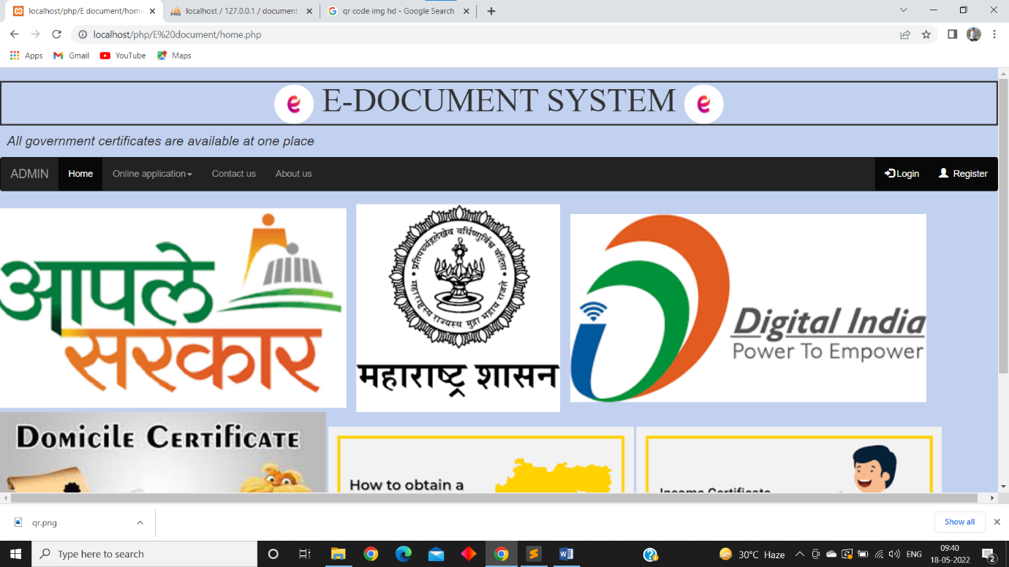

Register Form Page:

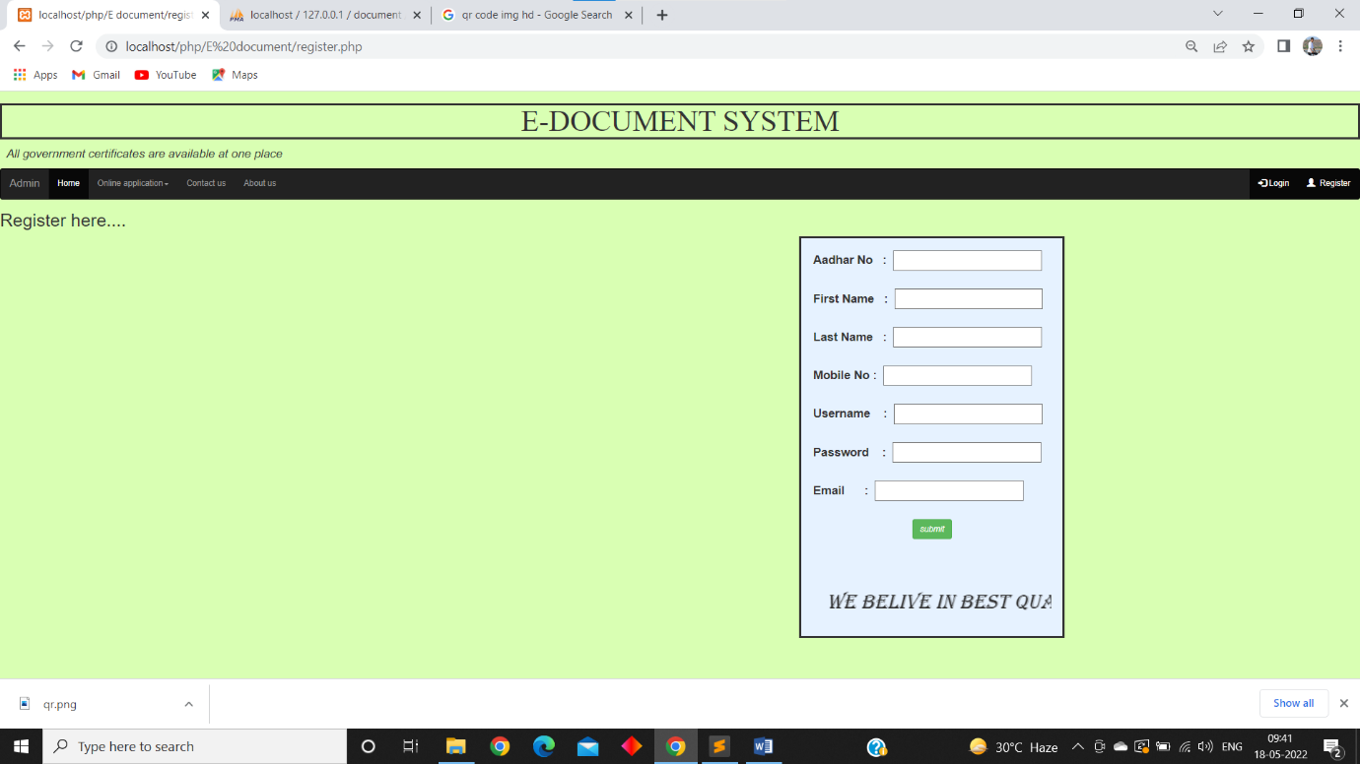

Application Form Page:

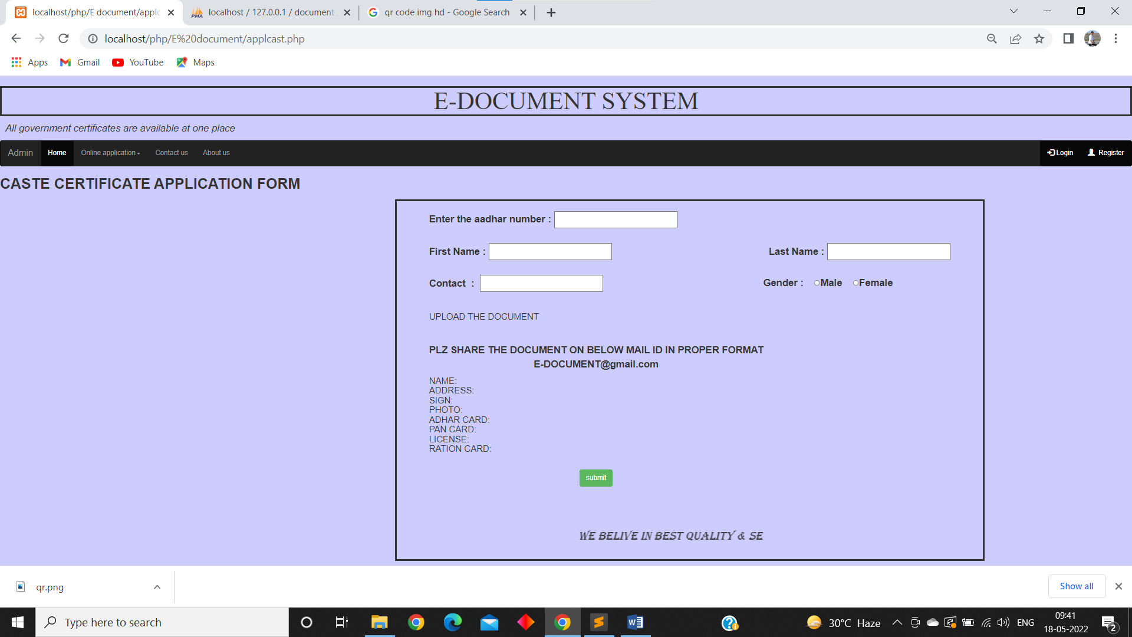

Admin Page:

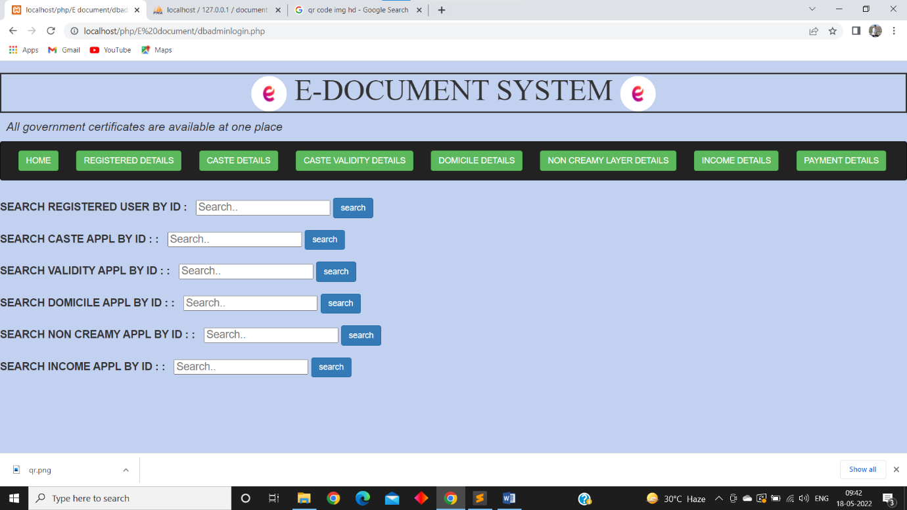

Validity application:

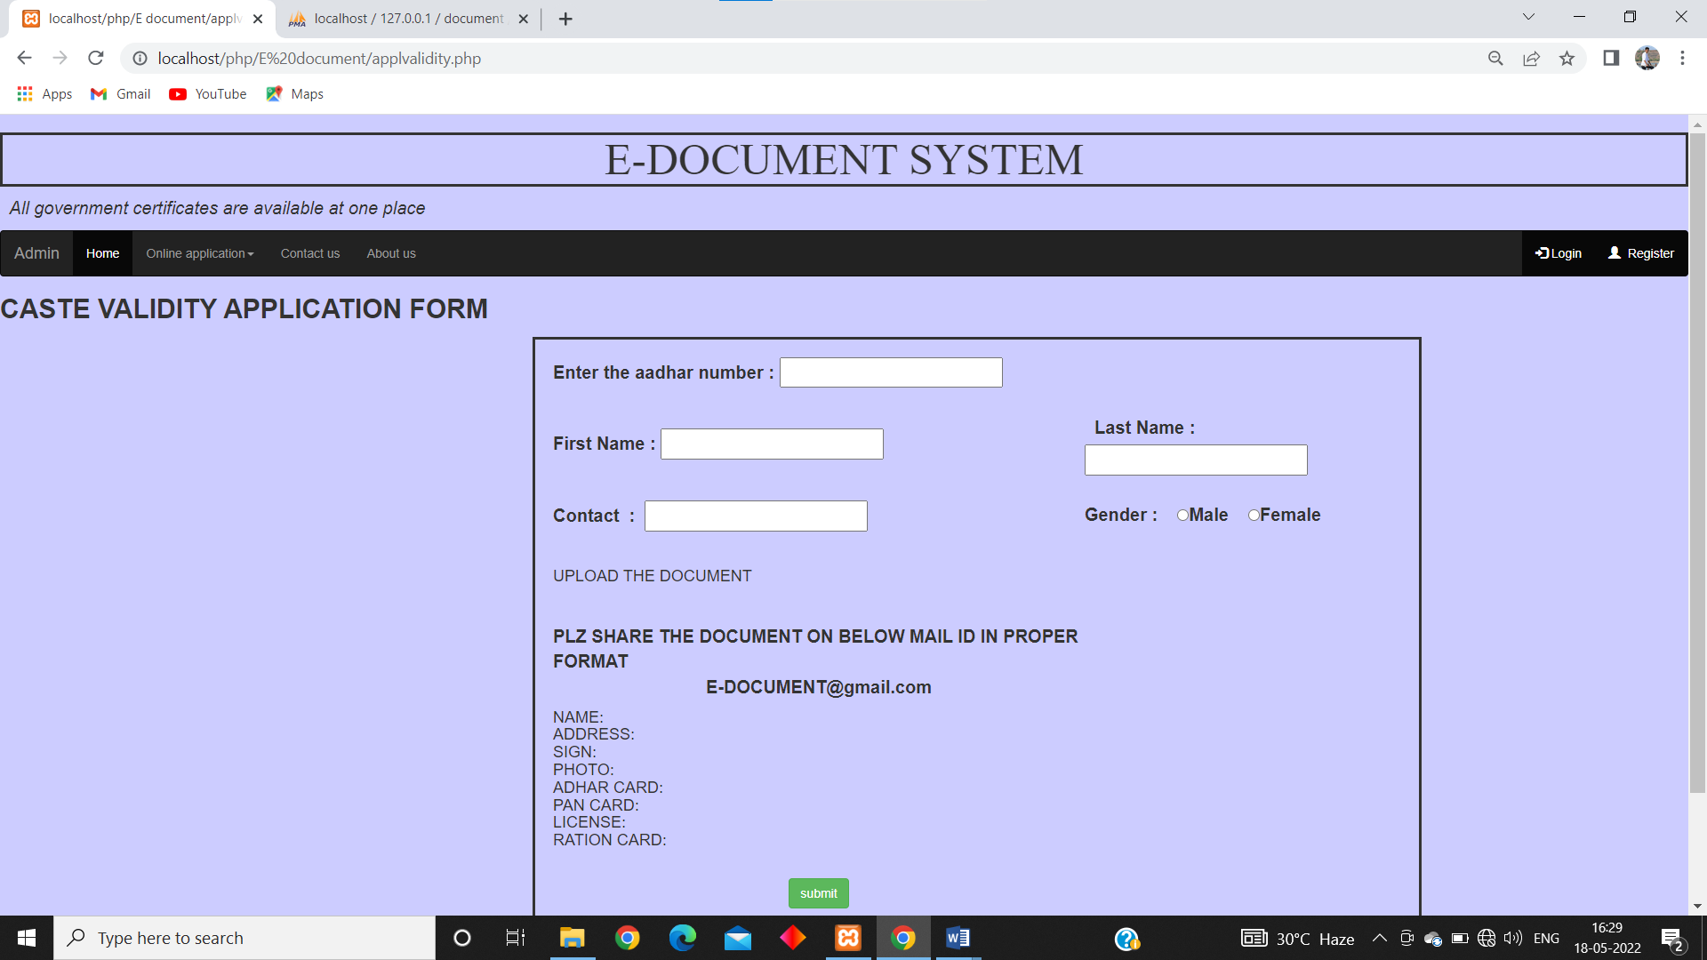

Domicile application:

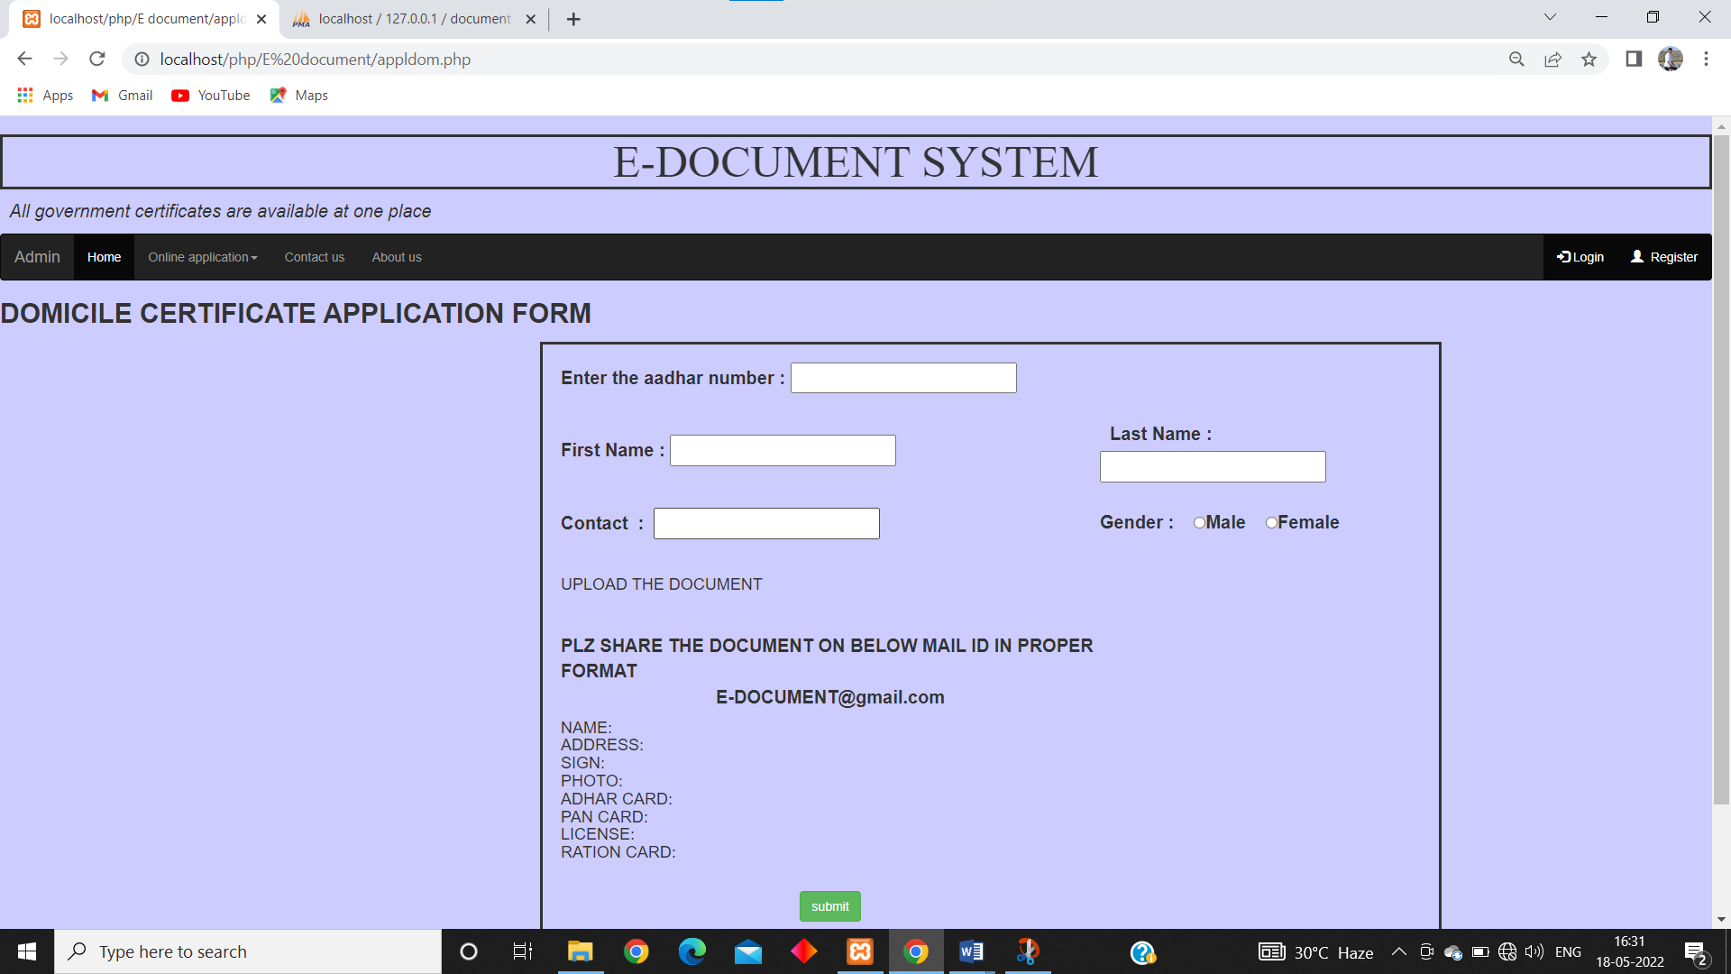

**Software /Hardware Specification**

**Hardware Requirements:**

**Client side / server side:**

|  |  |
| --- | --- |
| RAM | 4 GB |
| Hard disk | 1 TB |
| Processor | AMD Ryzen 5 ghz |

**Software Requirements:**

**Client side:**

|  |  |
| --- | --- |
| Web Browser | Google Chrome or any compatible browser |
| Operating System | Windows or any equivalent OS |

**Server side:**

|  |  |
| --- | --- |
| Web Server | APACHE |
| Server side Language | PHP |
| Database Server | MYSQL |
| Web Browser | Google Chrome or any compatible browser |
| Operating System | Windows or any equivalent OS |

**Output And Report Testing:-**

Screenshot And Report

**Total Customer Reports:**

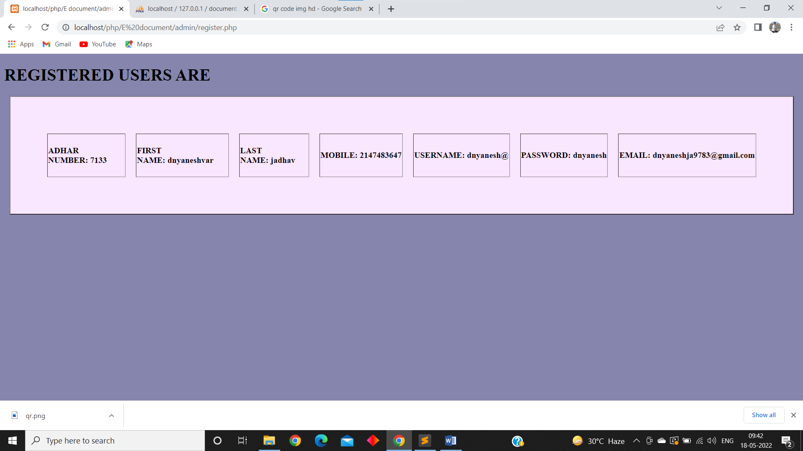

Total cast Certificate Application:

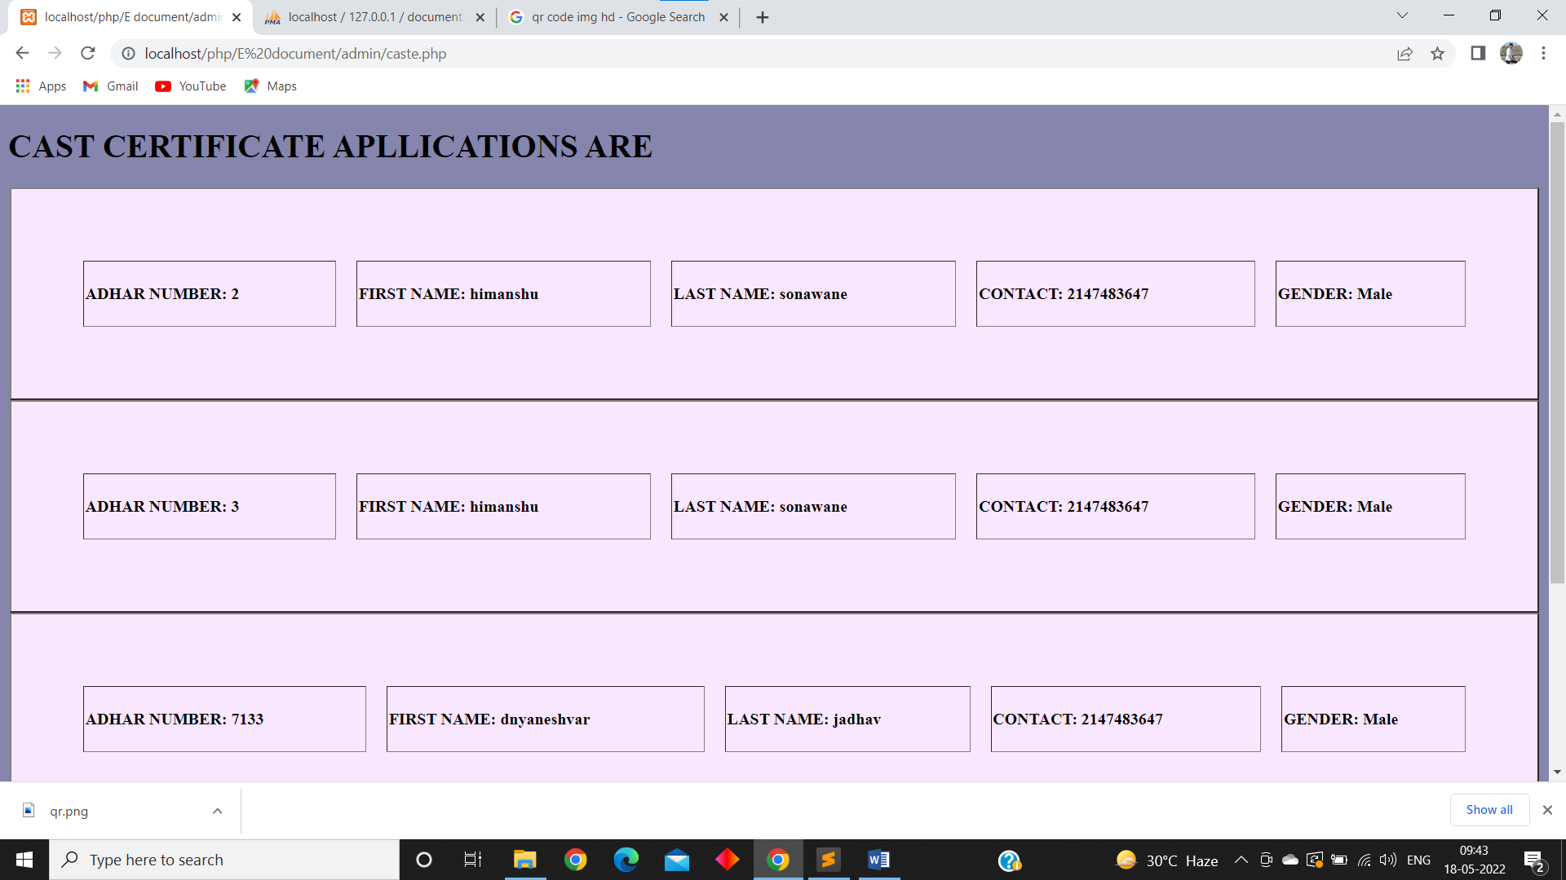

Total Validity Certificate Reports:

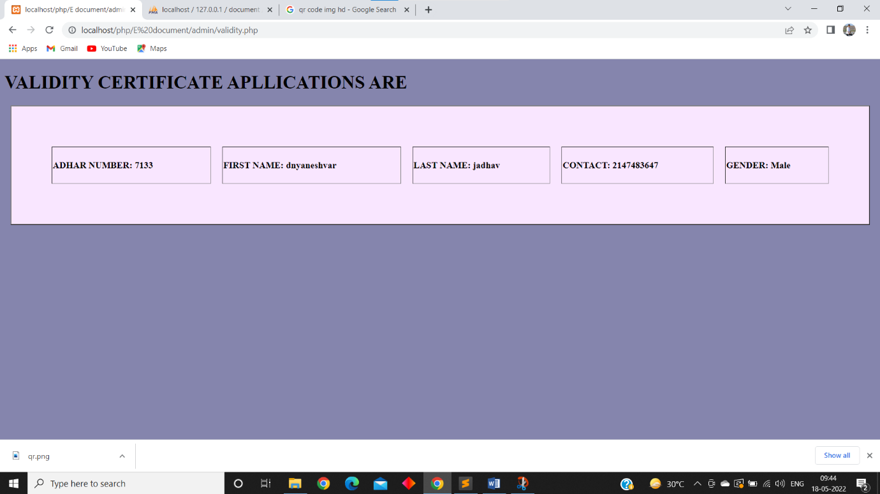

Total domicile Certificate Reports:

